Websites & Features:

<https://www.seedlipdrinks.com/>

Really simple design, but I particularly like the menu because the other menu items fade when hovering on an option. It’s a nice twist on the regular highlighting-the-hovered-item feature.

<https://studiokraftwerk.com/work>

I really like the overlapping boxes on with the projects and their description. I’ve been thinking about how I want to layout my research content on my own website and this might be a great option. I also love how the text fades in as you scroll further. i_Xperience’s website does this too and it looks really nice. Their more in-depth project description is engaging too because there is very little explanatory text and more pictures, trying to illustrate the user experience instead of just describing it.

<http://pharrellwilliams.com/>

I love all of these tiles! Each time you hover, the blob of color expands to reveal more text. Additionally, when you hover towards a certain direction of a screen, the screen view shifts subtly in that direction. I can see how to maybe get the blob thing to work on hover, but the screen view thing would have to be JavaScript and not really useful to me because I don’t think I will have a page with lots of tiled items.

<http://dismoielliot.fr/>

I really like the script animation thing for the title page. Gabe mentioned it would be do-able in Illustrator so I may consider doing that for my name on my home page and then I can figure out a more unobtrusive logo for the rest of my pages, if I even decide to use one at all.

Resume Page – Essentially a collection of images: Top section is “Education"



Resume Page – Scrolled further down: “Work Experience” Section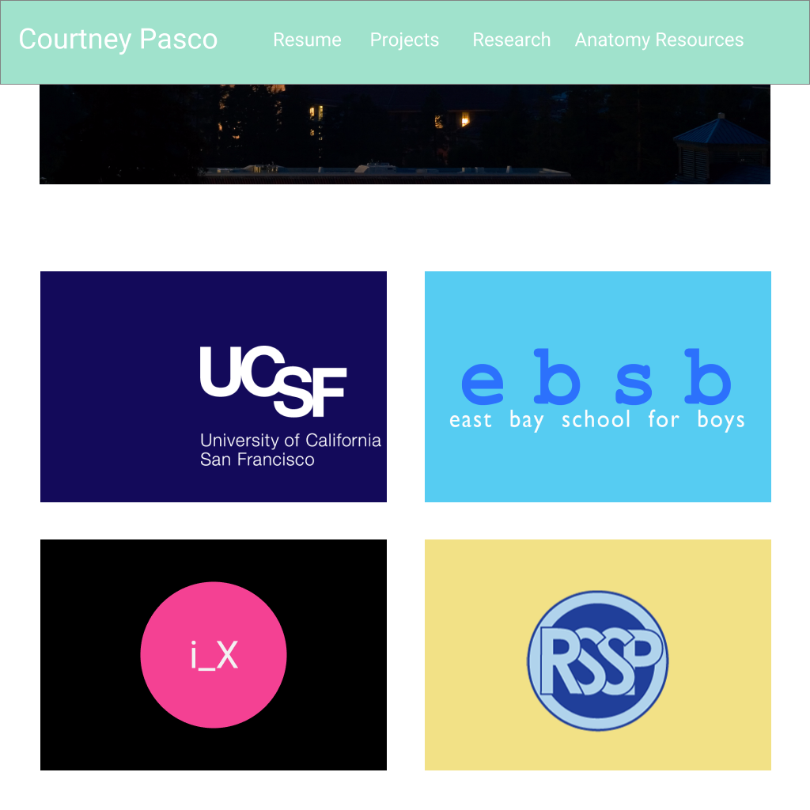

Resume page with hover – the images will have text overlay with the details

Research Page: I’m still not sure about the colors, but I think I ultimately want to trace the process of scan -> results with a little tracing line.

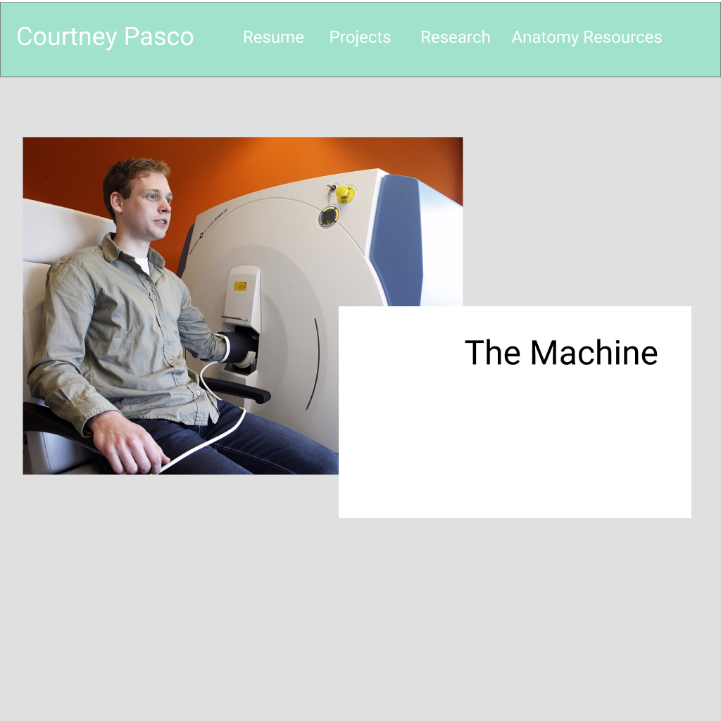

Here’s the tracing line example. It won’t just go from one thing to another, it will branch and merge at some points too.

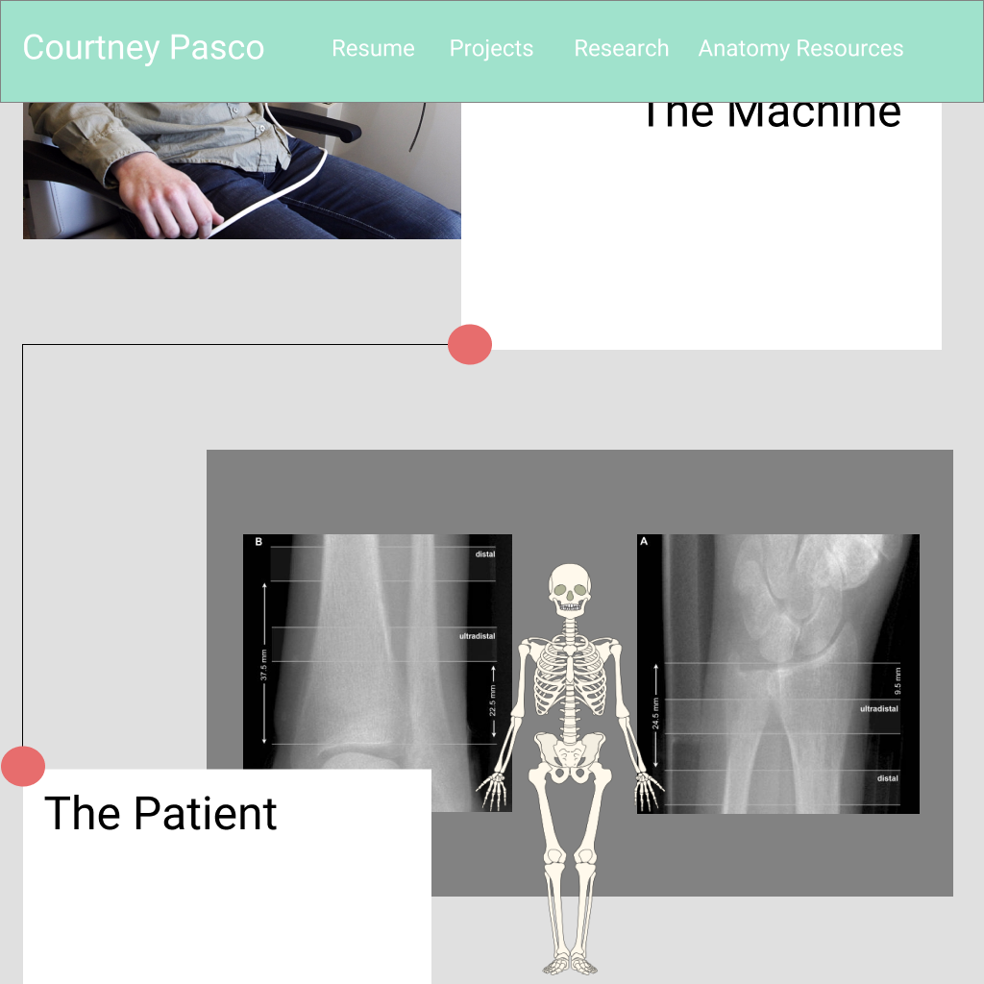

These are my Anatomy Resources. My hope is this will be a slideshow of images that represent each week’s lab. If you hover on the image, then an overlay will appear with links for additional resources. Hovering on a button enlarges it, pushes it up, and reveals the label.

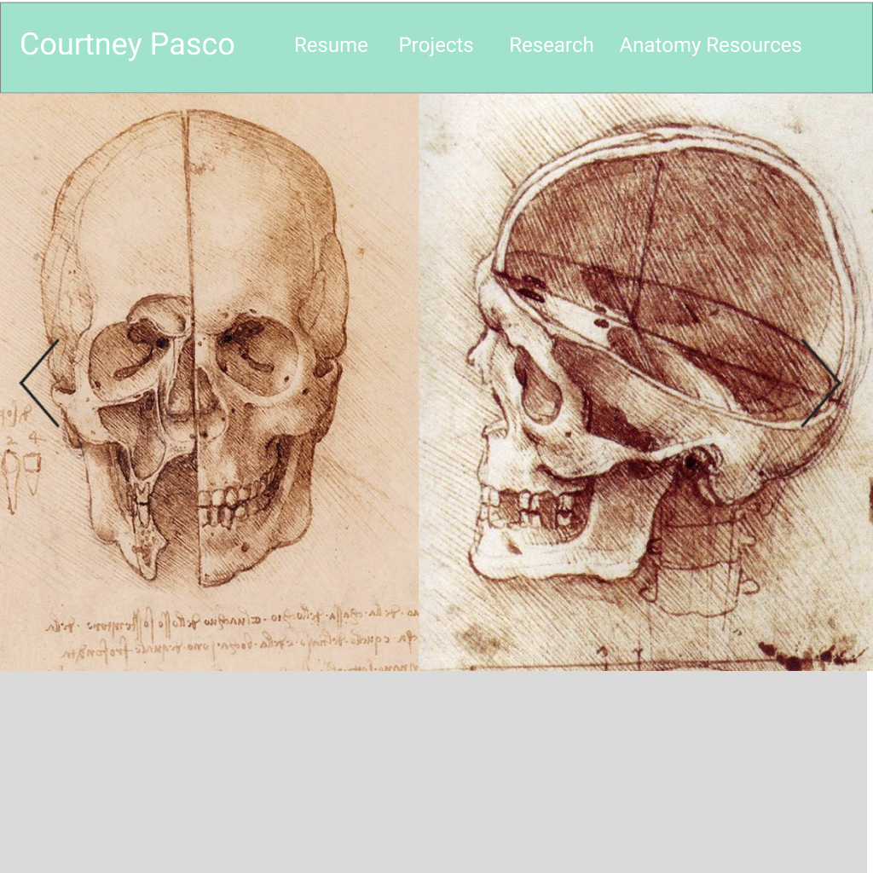

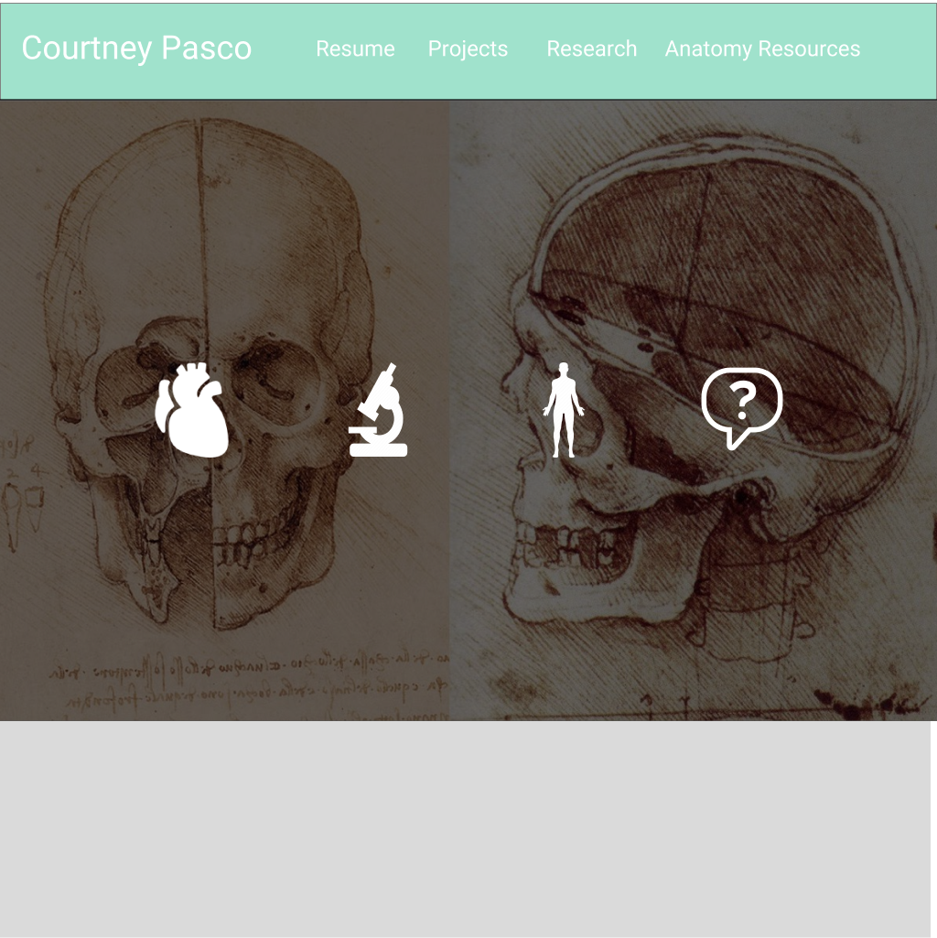

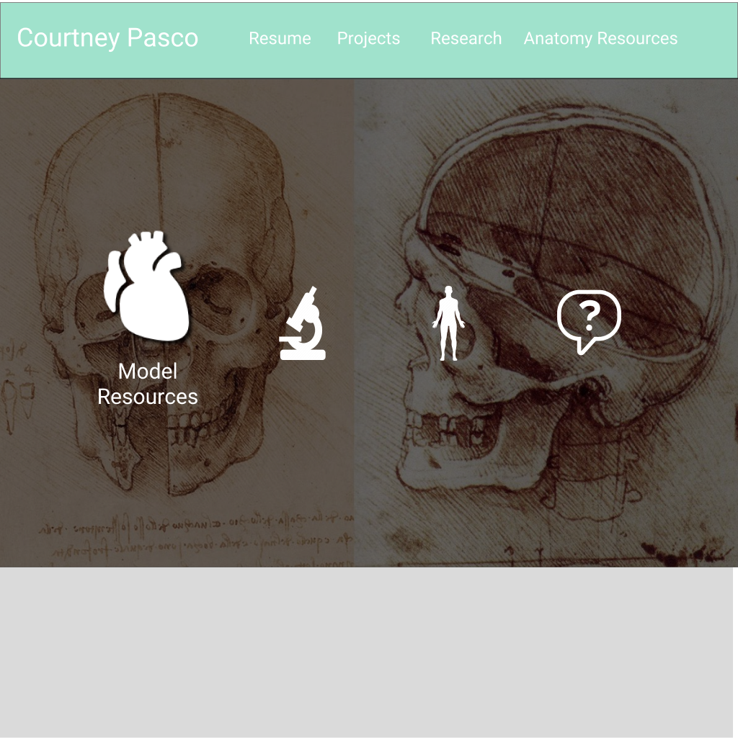

My idea for the projects screen is that when you hover over the project window, it will slide to the full width of the screen, revealing the description text and a link to it’s Github.

